In the spirit of global collaboration and support CIMA, British Underground and Sounds Australia partnered to present the inaugural Country Connections Live – A Showcase of emerging Americana artists from Australia, Canada and the UK, an exciting online special event during Thriving Roots 2020. Presented by the Americana Music Association Foundation, Thriving Roots: A Virtual Community Music Conference is a brand-new event. Attendees experienced an interactive conference with almost 100 online sessions.

Country Connections Live featured live performances alternating between artists from Australia, Canada and the UK. Four acts from each country performed 2 songs a piece making up the 2-hour showcase special. Canadian showcasing artists included: AHI, Julian Taylor, Mama’s Broke and Mo Kenney.

- Canadian Presence: The four Canadian showcasing artsits during the inaugural Country Connections Live were AHI (ON), Julian Taylor (ON), Mama’s Broke (NS) and Mo Kenney (NS). Each artist had a participating company rep who attended the conference and took part in the showcase event.
- Marketing & Promotion: Specific marketing and promotion initiatives included: press and promotion though the CIMA website, newsletter and social media properties prior to and during the event.
- Outcomes: Participants had the opportunity to partake in 10 meetings throughout the conference. In total over X delegates watched the Country Connections Live showcase.

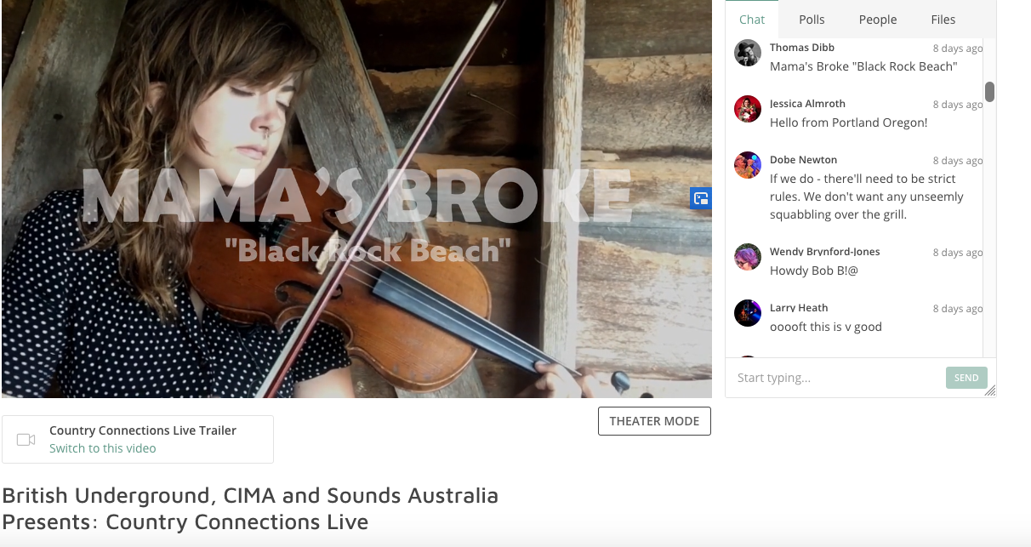

Screenshot of Mama’s Broke at Country Connections Live

