CIMA returned to Brighton, UK this May for the 2023 edition of The Great Escape. As the UK’s premier new music and industry gathering, TGE is where sectors from the entire UK music industry come to network, make deals, and grease the wheels of the industry.

This year, CIMA partnered with Alberta Music, Manitoba Music, Music BC, Music Nova Scotia, MusicOntario, SaskMusic and SODEC, to present 3 full afternoons of Canada House showcases at The Green Door Store. A Country Connections networking session presented by Music From Ireland was held on Thursday morning at Kooks and gave Canadian delegates the opportunity to meet with internationals from Ireland, the UK, Australia, New Zealand and more. Prior to TGE, a pre-event was held on the Tuesday in London at Strongroom which included two speed meeting sessions and a showcase highlighting 10 Canadian acts.

- Canadian Presence: The Canada House showcase featured performances performances from 18 artists over 3 days: Bibi Club, Boslen, Cassidy Mann, Ellen Froese, Ellevator, Fernie, Georgia Harmer, Haley Blais, Katie Tupper, Mouraine, Odreii, OMBIIGIZI, Pillow Fite, Rebecca Lappa, Slow Leaves, STORRY, Vanille and Yohvn Blvck. 15 Canadian companies took part in the business events on site during The Great Escape 2023.
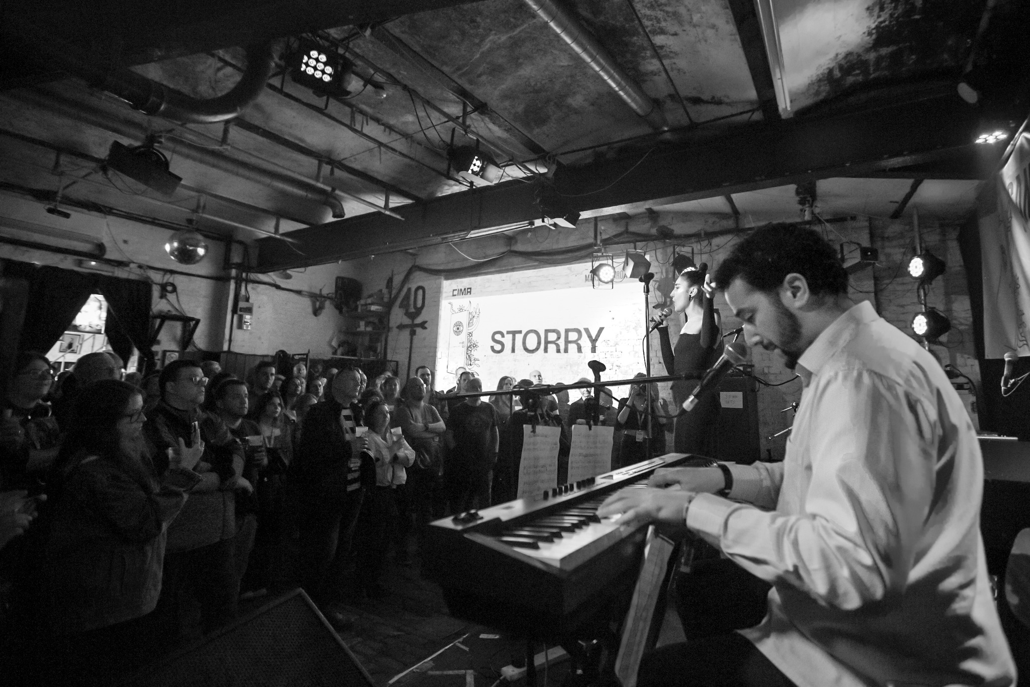
- Marketing & Promotion: CIMA hired a UK based consultant to help facilitate the speed meetings in London and invite industry professionals out to Canada House in Brighton. CIMA also hired a UK publicist who worked with the Canadian artists on various media coverage which included writeups in The Line of Best Fit, DORK, NOTION & more as well as video coverage and interviews for 8 artists. CIMA worked with The Great Escape to promote the showcase on the festival’s website and social media. Promotional efforts also included posts on CIMA’s social media platforms, website and in the weekly newsletter blasts.
- Outcomes: Post survey results indicated that the Canadian companies made 158 new contacts and connected with 181 existing contacts while at TGE. They took 106 meetings that resulted in participants reporting they started/finalized 62 business deals. According to the participants, the real and expected revenues associated with these deals over the next 36 months is $542,000 generated from their business activities at The Great Escape 2023.

