CIMA was back, in person, at SXSW 2023 for two full days of showcases t Canada House in Austin, TX. Swan Dive transformed into all things Canadian on Wednesday, March 15 and Thursday, March 16 and featured 23 incredible acts from across the country. Canada House showcasing partners included: Alberta Music, Manitoba Music, Music BC, Music New Brunswick, MusicOntario, SaskMusic and the City of Toronto.

Ontario Creates, in partnership with ARHT, hosted a very special presentation on Wednesday at Canada House: A conversation about the future of Music and Technology with SXSW’s own Hugh Forrest (Co-President and Chief Programming Officer) and an interactive holographic performance .

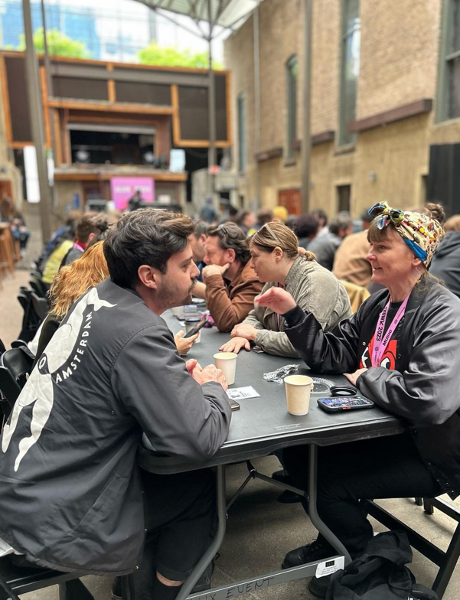
- Canadian Presence: The 23 showcasing acts at Canada House this year were: Aysanabee, Balaklava Blues, Begonia, Boy Golden, Haley Blais, JayWood, Julie Doiron, Kaia Kater, Lex Leosis, Living Hour, Mariel Buckley, MAUVEY, Motherhood, Peach Luffe, Poolblood, Skye Wallace, Snotty Nose Rez Kids, Softcult, TALK, The Garrys, The Hypochondriacs, William Prince & Winona Forever. Both days of showcases kicked off with a BBQ which allowed delegates the chance to mingle with Canadian and International industry. Canadian companies also participated in the Country Connections “It’s a Small World” speed meeting session at the British Embassy on Saturday, March 18.
- Marketing & Promotion: Promotional efforts included posts on CIMA’s social media, website and weekly newsletter blast.
- Outcomes: Post survey results indicated that the Canadian companies made 151 new contacts and connected with 180 existing contacts while at SXSW. They took 115 meetings that resulted in participants reporting they started/finalized 34 business deals. According to the participants, the real and expected revenues associated with these deals over the next 36 months is $263,000 generated from their business activities at SXSW 2023.

